**Daily Stand-Ups Team Meeting Brief Log**

**Meeting 1**

time: 1:30—3:10 pm

Date: 19/04/18

sHORT MEETING(First 10 mins)

LOG ENTRY:

What did you do yesterday?

Deng installed unity and search the practice resources for members training

Zhi Cui installed unity and search the resources for him tasks

Sam installed unity and search the resources for him tasks

Bin Jiang installed unity and search the image resources for whole game interface

What will you do today?

Everyone study how to use unity.

Are there any impediments in your way?

None.

Duration: 1 hour and a half

Venue: WT302

Agenda:

* Integrating resources that we found before this meeting
* Demonstrate basic operation of how Unity starts to build a new project and discuss some components in Unity and make sure all team member got a basic version of using Unity.
* Assign a very small task for every team member to do simple clock from this link: <http://catlikecoding.com/unity/tutorials/basics/game-objects-and-scripts/>

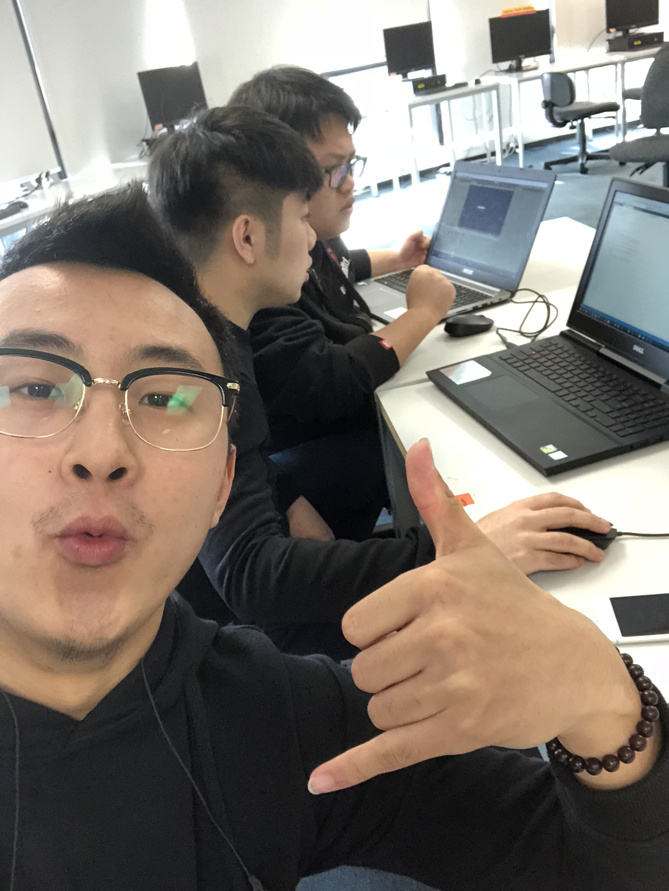

**Meeting 2**

time: 2:00—3:00 pm

Date: 20/04/18

Duration: 1 hour

Venue: WT302

Agenda:

* Showing the simple task of clock that assigned last meeting
* Discuss and confirm the resources or online tutorial whether is correct or not and start doing your own tasks that assigned at the start of Sprint 1

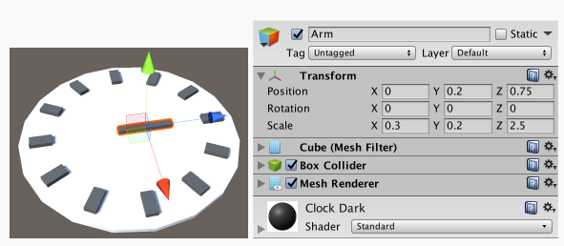

**Meeting 3**

time: 2:00—3:00 pm

Date: 24/04/18

Duration: 1 hour

Venue: WT302

Agenda:

* All team members showing how is going on your own tasks
* Discuss the blockage with Scrum Master that you met
* Think of if we finish this game finally how to play it on Android mobile phone, go to find resources or online tutorial.

**Meeting 5**

time: 2:00—5:00 pm

Date: 27/04/18

Duration: 3 hours

Venue: WT302

log entry:

* With the help of Scrum Master, we integrate the codes and every piece of tasks in Sprint 1
* Still have to figure out how to play this game on android mobile
* Start doing unit test
* Check the assessment 2 that what should be delivered in Sprint 1

**Meeting 4**

time: 1:00—3:00 pm

Date: 25/04/18

Duration: 2 hours

Venue: WT302

Agenda:

* Tying to play finished task on android mobile phone by following online tutorial
* Scrum Master helps unfinished tasks
* Discuss how to do unit testing and have to send an email to Sheetal to confirm after the day.